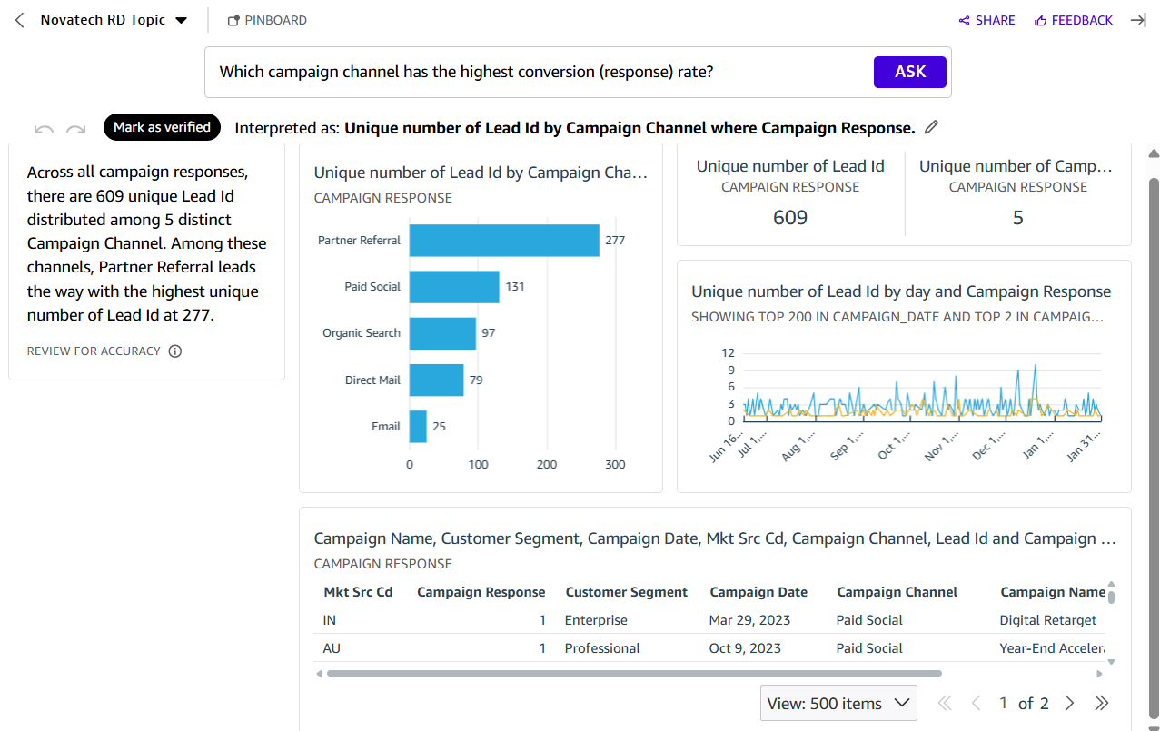
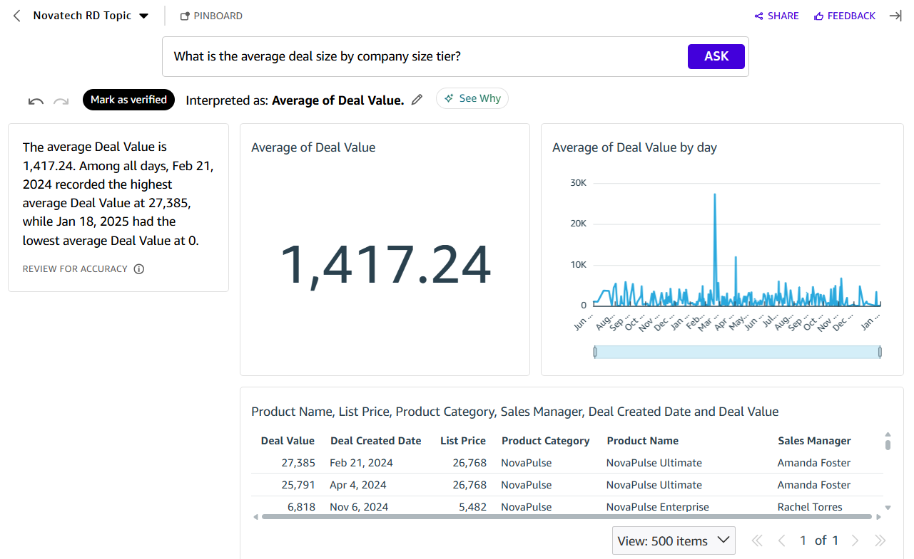
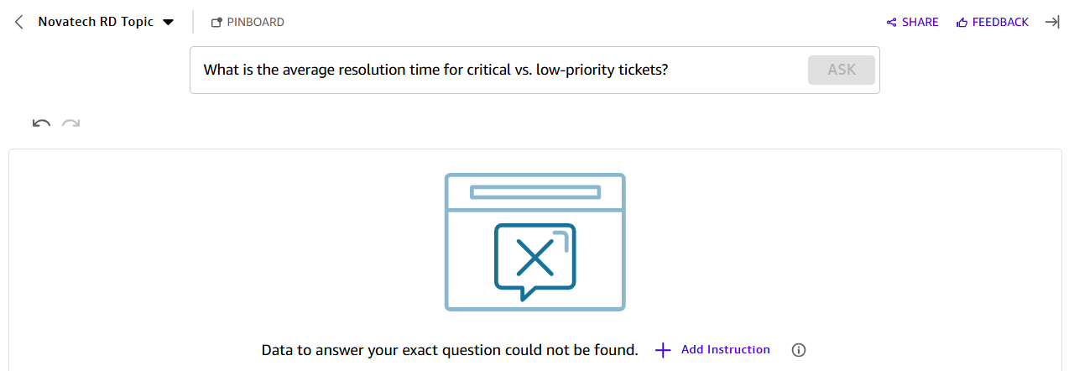
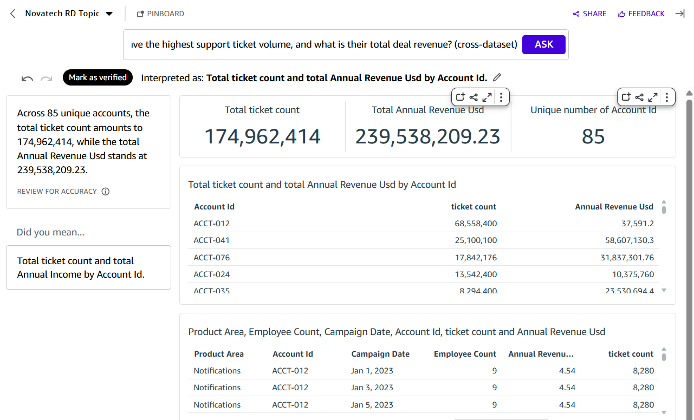
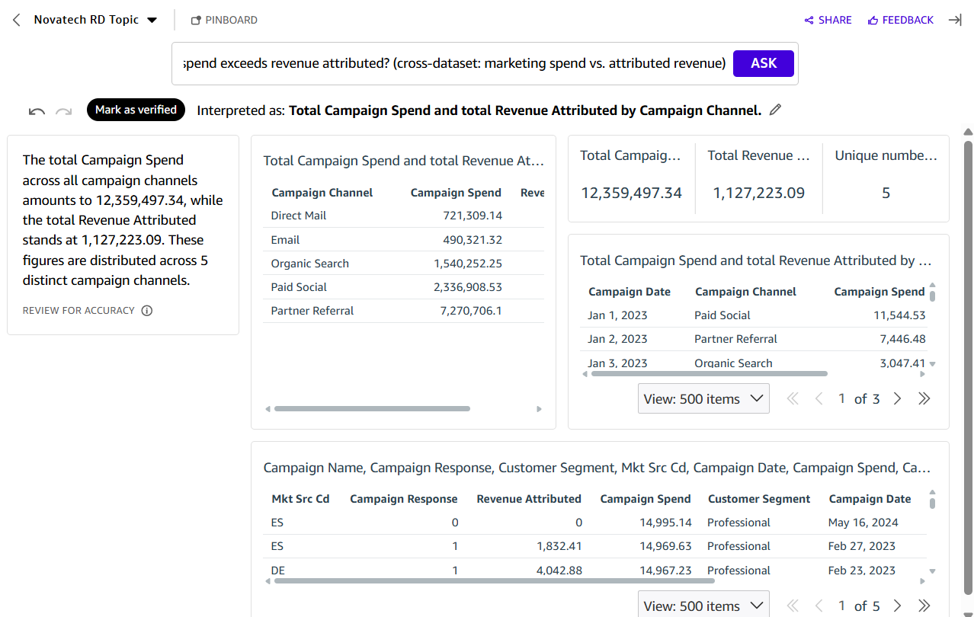
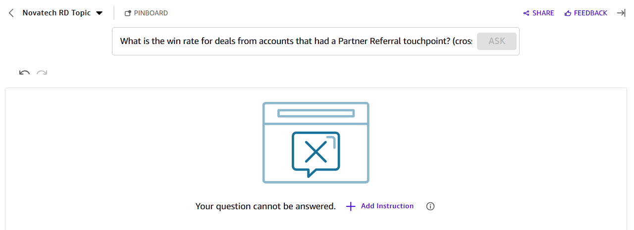
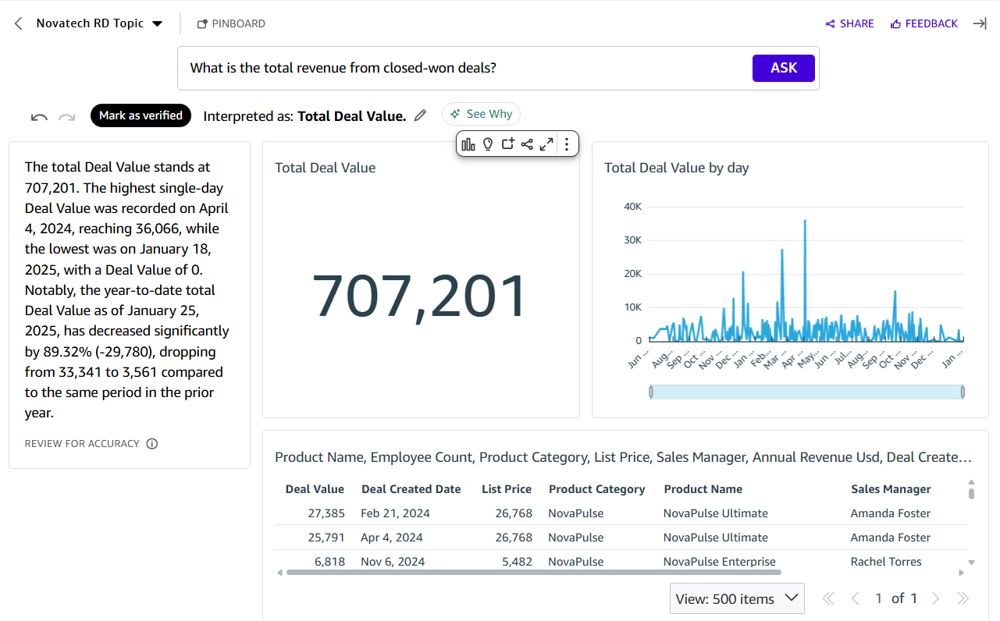
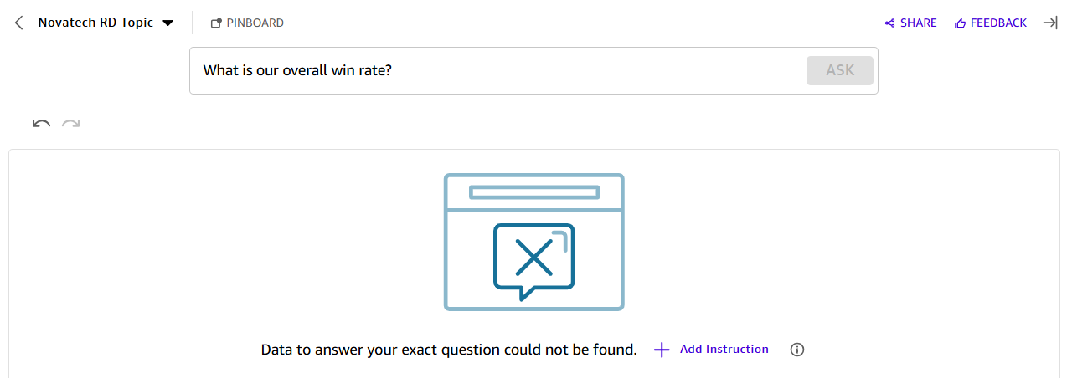
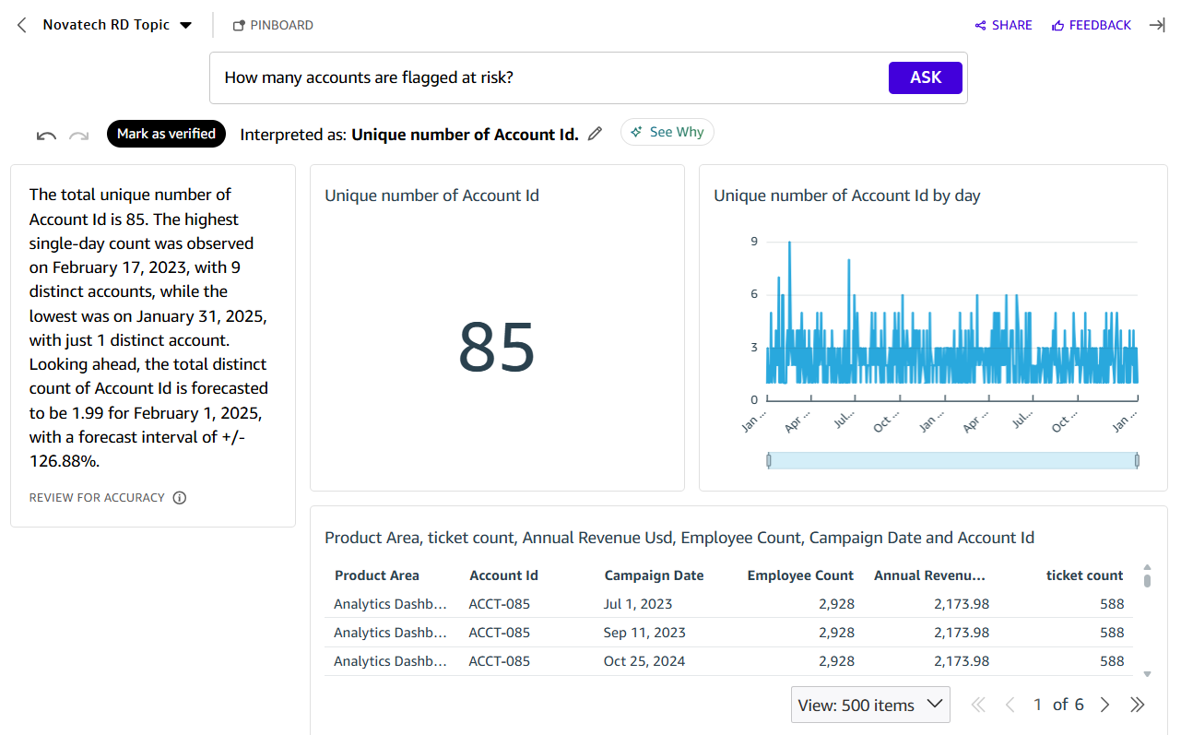

Reflection:
1. Where did Q agree with the dashboard?
Only on the single-source, correctly-scoped question: spend vs. revenue by channel (Q5) returned per-channel figures that matched the dashboard exactly, confirming every channel spends more than it earns back in attributed revenue. This was also our only cross-dataset question that Q handled correctly.

2. Where did Q disagree or struggle, and why?
Everywhere else. Two distinct failure patterns showed up. First, Q sometimes answered a different question than asked: for "highest conversion rate," it silently substituted response count for response rate, naming Partner Referral instead of Direct Mail; for "average deal size by tier," it dropped the grouping dimension entirely and returned one undifferentiated average. Second, on the two questions that most depend on the joined dataset's structure — top ticket-volume account with deal revenue, and Partner Referral win rate — Q either returned a number that's obviously wrong (a ticket count of 174 million against a 3,000-row support dataset, a clear symptom of the join's row fan-out with no de-duplication applied) or refused outright. Topic configuration clearly did not teach Q to reason about our level-aware calculated fields, and it doesn't distinguish "rate" from "count" or preserve a requested grouping without very literal phrasing.

3. When would you use Q vs. the dashboard?
Only for the narrowest, most literally phrased single-source questions, and always with a "review for accuracy" mindset — Q labels its own answers this way for good reason. Anything involving a rate, a grouped comparison, or the unified/joined dataset should go to the dashboard, where the visuals encode the correct aggregation logic (including the fan-out fix) that Q currently can't reproduce on its own. In practice, the dashboard is the source of truth for the team's Monday-morning questions, and Q is better suited to being pointed at specific dashboard numbers to confirm rather than trusted for open-ended cross-dataset exploration.

